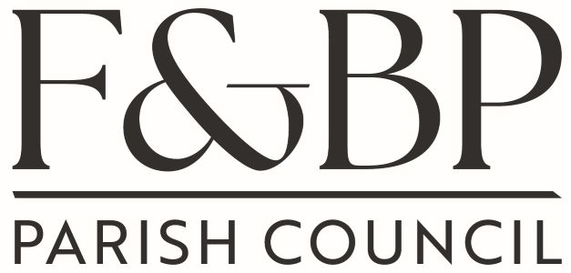
Filkins & Broughton Poggs Parish Council
Please address all correspondence to the Parish Clerk:
Mrs. Christine Hoad, Wynwood Filkins, Lechlade, Glos. GL7 3JG
Tel: 07379 378402 E mail: clerk@filkins.org.uk

29 April 2026

You are hereby summoned to attend the next meeting of Filkins & Broughton Poggs Parish Council which will be held on Tuesday 5 May 2026 after the Annual Parish Meeting in Filkins Village Hall. Members of the public are invited to attend.

- Election of Chair
- Election of Vice Chair
- Signing of Declarations
- Apologies for Absence
- To receive Declarations of Pecuniary, personal or prejudicial interest in respect of matters contained in the agenda, in accordance with the provisions of the Localism Act 2011 in respect of members and in accordance with the provisions of the Local Government Act 1972 in respect of Officers.
- Adjournment for Public Participation for items not raised in the Annual Parish Meeting only. Members of the public wishing to speak will each be given the opportunity to address the council for 3 minutes.
  - Ian Grey – Confirmation of agreed design by the Trustees – next steps
7 Working Parties
7.1 To confirm Working Parties for 2026/27
8 Minutes
8.1 To accept minutes of last Parish Council meeting 17 March 2026
8.2 Matters for information only arising from these last minutes
9 Monthly Working Party Updates
9.1 Planning Cllr Howe, Jones, Robbins
Applications received after the agenda has been posted but on the WODC website may be discussed at the meeting.
9.1.1 26/00790/FUL – Brades Cottage solar panels of garage
9.1.2 26/00785/HHD – Goodfellows – 2 storey extension to replace flat roof and dormers
9.1.3 26/00852/FUL - Furzey Hall Farm – Conversion of barn to separate live/work unit
10 Finance
10.1 Audit: progress report – June meeting
10.2 To resolve and approve the payments for April /May 2026 – Parish Council & Village Centre and account balances
10.3 Review of Asset Register & Risk Assessment
10.4 Review of Insurance Policy – if received
10.5 Website progress
11 Acceptance of Standing Orders
12 Acceptance of Financial Regulations
13 Date of next Parish Council meetings 2026 - 16/06, 21/07, 15/09, 20/10, 17/11, 15/12, 19/01, 16/02,16/03

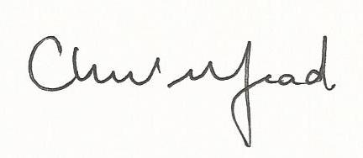

Cris Hoad
Clerk to the Council

